Software Requirements Specification Template

General System Description

System Overview – briefly describe the system being designed. 1-3 paragraphs
This is a systems overview of the information system we’re building for a florist. The system will be designed to manage the process of ordering and delivering flowers. The system will give customers the option of choosing from 10 standard arrangements, customers will have customizable options of small, medium, or large, and provide customers with 5 different options of decorations. The system will have a reliable payment process, ordering, and delivering system.
The system will assist staff in various processes. Processes like monitoring the number of deliveries made a day, a way of taking down delivery addresses and time. A way of knowing the type of flowers ordered and decorations for those orders. A way of communicating with the floral supply house, a way of looking up upcoming orders, and a way of placing upcoming orders after customers have requested an order.

1.2 System Scope- describe how much of the system is being described in this document. 1 paragraph
The scope talks about part of the system implemented in software. Based on the problem description the only thing not implemented in software will be the physical delivery of the flowers, and the calls made by the customer. That is, arrangement selection, client customization, decoration options, payments made by customers, and orders managed by employee, will all be implemented in software.

2. Functional Requirements Listing
Number of subsystems is variable- divide the system into various subsystems based on use case analysis.

2.1 Placing Order
Reqt ID | Requirement Text
SS1 -1 | The system shall be available for orders to be made
SS1 -2 | The system shall provide a number for customer to make an order by phone call
SS1 -3 | The System shall give customers the option to order online

2.2 Order Options
Reqt ID | Requirement Text
SS1 -1 | The System shall give customers the option of 10 different arrangements to choose from
SS1 -2 | The system shall give customers the option of different flowers
SS1 -3 | The system shall give customers customizable options of small, medium, or large.
SS1 -4 | The system shall give customers 5 different decoration options

2.3 Payment
Reqt ID | Requirement Text
SS1 -1 | The System shall provide an option of payment
SS1 -2 | The system shall make third party payments like (PayPal, Venmo, Zelle, or Square) available
SS1 -3 | The system shall provide a way of telling customers payments are due at time of order

2.4 Delivery
Reqt ID | Requirement Text
SS1 -1 | The system shall have a way pf keeping track of existing deliveries
SS1 -2 | The system shall only give customers the option to book 10 deliveries a day
SS1 -3 | The system should display the max number of deliveries allowed

2.5 Staff Monitoring
Reqt ID | Requirement Text
SS1 -1 | The System shall provide staff with a way of confirming the deliveries haven’t exceeded 10 for a day
SS1 -2 | The system shall provide staff with a way of taking down delivery address and time
SS1 -3 | The system shall provide staff with a way of taking down number of flowers ordered
SS1 -4 | The system shall provide staff with a way of taking down type of flowers ordered
SS1 -5 | The system shall provide staff with a way of taking down decorations for order
SS1 -6 | The system shall provide staff with a way of communicating with the floral supply house
SS1 -7 | The system shall provide staff with a way of looking up upcoming orders
SS1 -8 | The system shall provide staff with a way of Placing upcoming orders

2.6 Notification
Reqt ID | Requirement Text
SS1 -1 | The System shall provide arranger with next day’s deliveries
SS1 -2 | The system shall provide delivery staff with current day deliveries

3. Nonfunctional Requirement Listing

3.1 Security
Reqt ID | Requirement Text
NF-1 | The system shall use a third-party payment application to enhance security
NF-2 | The system shall allow an employee to view only information authorized for his/her position
NF-3 | The system shall store customer order information
NF-4 | The system shall store customer personal information
NF-5 | The system shall protect the integrity of arrangements provided to customers
NF-6 | The system shall protect the integrity of customization options
NF-7 | The system shall protect the integrity of decoration options
NF-8 | The system shall protect the integrity of our notification option
NF-9 | The system shall protect the integrity of our delivery process

3.2 Availability
Reqt ID | Requirement Text
NF-1 | The system shall make Order options available
NF-2 | The system shall make Order modifications available
NF-3 | The system shall make payment options available
NF-4 | The system shall be available to customers unless ongoing maintenance are in progress
NF-5 | The system shall display maintenance hours to customers
NF-6 | The system shall display required menus to employees
NF-7 | The system shall send notifications to employees
NF-8 | The system shall show delivery information to employee

3.3 Performance
Reqt ID | Requirement Text
NF-1 | The system shall respond quickly to order lookups
NF-2 | The system shall respond quickly to Order modifications
NF-3 | The system shall process payments quickly
NF-4 | The system shall respond quickly to employees when querying the database for information

3.4 Storage
Reqt ID | Requirement Text
NF-1 | The system shall store customer personal information
NF-2 | The system shall store order information
NF-3 | The system shall store payment information
NF-4 | The system shall store delivery information

4. Known issues/risks
Describe (if any) known issue with the system design
There are a few issues with the florist system. The first issue would be not listing what database we’re using to store customer information. We need to know what database as to know how secure it’ll be, and how it will aid with performance. Another issue would be not giving us a number for people our system can handle at a time. Next would be not giving us a time frame for system maintenance. Another issue would be not describing how fast you want the system to respond to users. Lastly, would be not providing the system with an option of recording calls as to prevent customers/employees from providing wrong information.

5. Appendix 1 – Use Cases
Include all use case tables and diagrams here – one subheading per use case.
5.1 Customizing Order
5.1.1 Selecting Arrangements
Name of use Case: | Select Arrangements
Actor(s): | User
Successful Completion: | - User chooses arrangements  - Arrangements successfully added
Alternatives: | Arrangements not available
Preconditions: | None
Postconditions: | Select Customization
Assumptions: | Arrangements are available

UML Diagram:
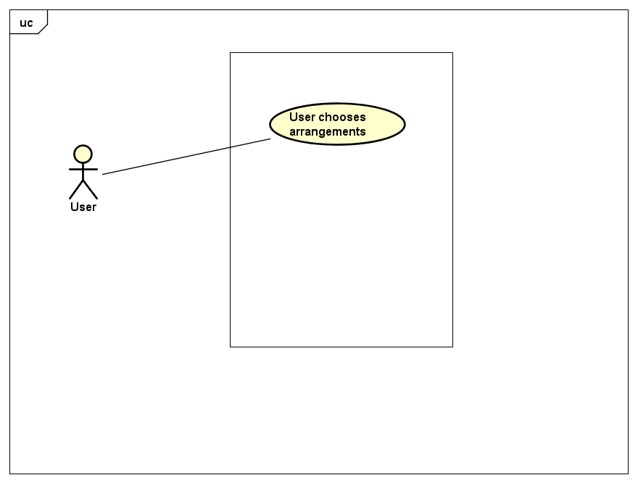

5.1.2 Select Customization
Name of use Case: | Select Customization
Actor(s): | User
Successful Completion: | - User selects Customization  - Customization Successfully added
Alternatives: | - Arrangements not selected  - Customization not available
Preconditions: | User has selected Arrangement
Postconditions: | None
Assumptions: | - Arrangements have been selected  - Customization options available (small, medium, large)

UML Diagram:
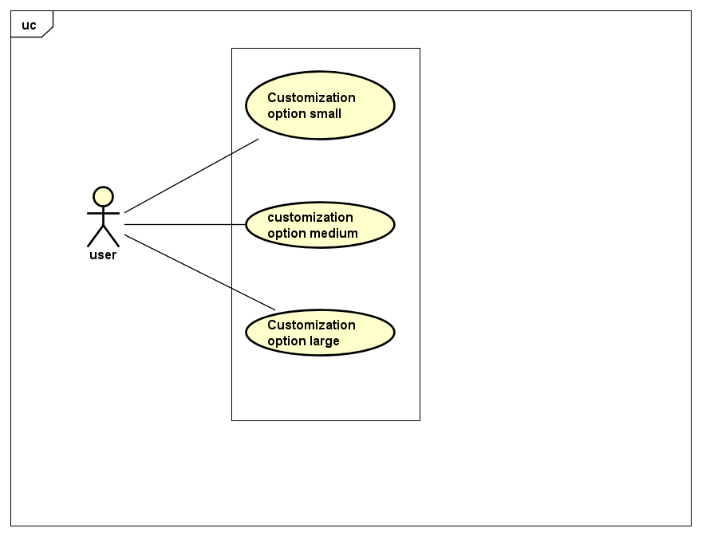

5.1.3 Select Decoration
Name of use Case: | Select Decoration
Actor(s): | User
Successful Completion: | - User Selects decoration  - Decoration successfully added
Alternatives: | - Arrangements not selected  - Customization not available  - Decorations option missing
Preconditions: | - Arrangements selected  - Customization selected
Postconditions: | None
Assumptions: | - Arrangements have been selected  - Customization have been selected (small, medium, large)  - Decoration option available

UML Diagram:
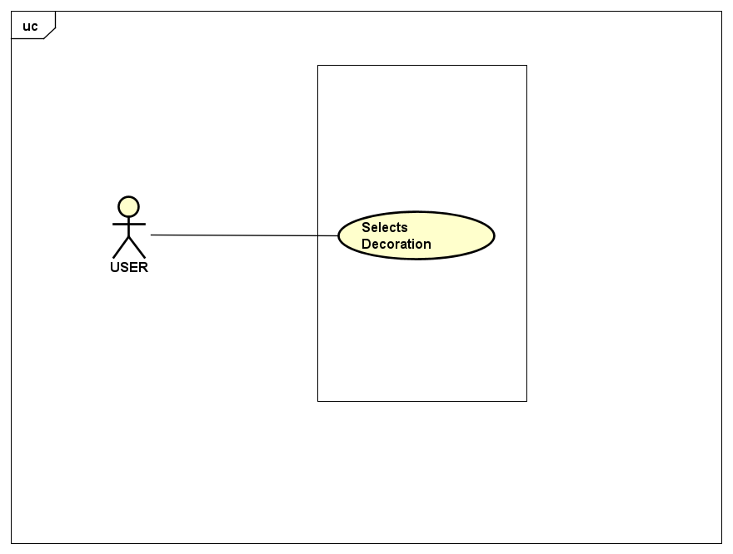

5.2 Delivery
Name of use Case: | Take down delivery information
Actor(s): | User, Receptionist
Successful Completion: | - Deliveries haven’t passed 10  - Takes down address and time
Alternatives: | - Deliveries surpasses 10  - Address and time not given
Preconditions: | - Makes order  - Pays for order
Postconditions: | None
Assumptions: | - Orders Have been made  - Payment have been received
UML Diagram:
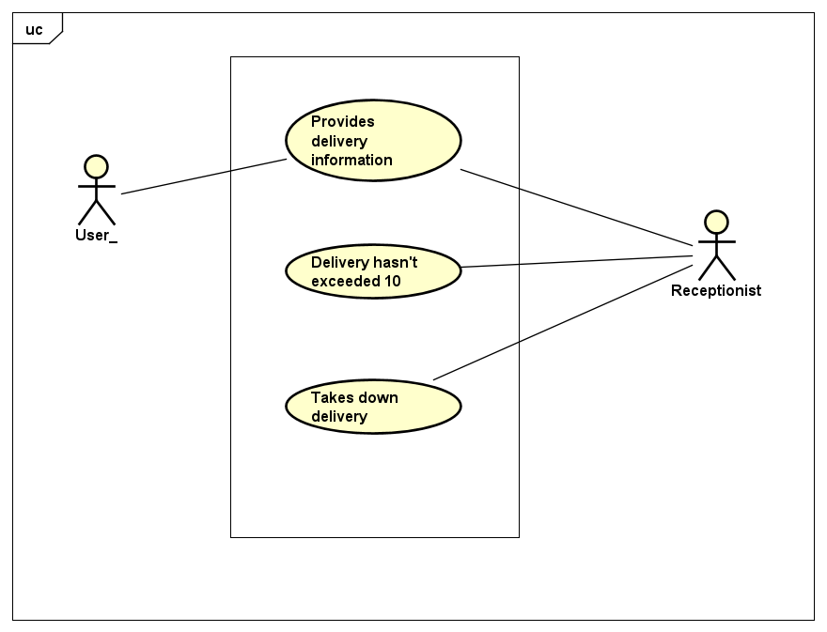

5.3 Making Orders
Name of use Case: | User makes Orders
Actor(s): | User
Successful Completion: | Order scheduled
Alternatives: | Order not scheduled
Preconditions: | - User has selected Arrangement  - User has selected customization
Postconditions: | - Payment to be made  - Delivery to be approved
Assumptions: | - Arrangements have been selected  - Customization have been selected (small/medium/large)

UML Diagram:
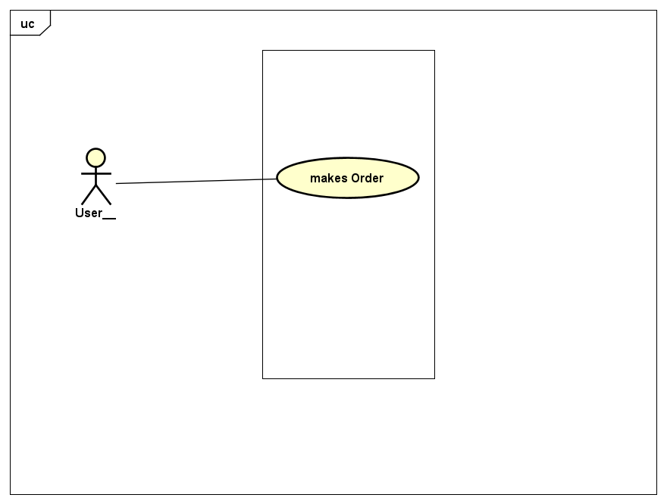

5.4 Payment
Name of use Case: | Customer makes Payment
Actor(s): | Customer
Successful Completion: | Payment Approved
Alternatives: | Payment rejected
Preconditions: | Made an order
Postconditions: | Order to be processed by employee
Assumptions: | Order has been made

UML Diagram:
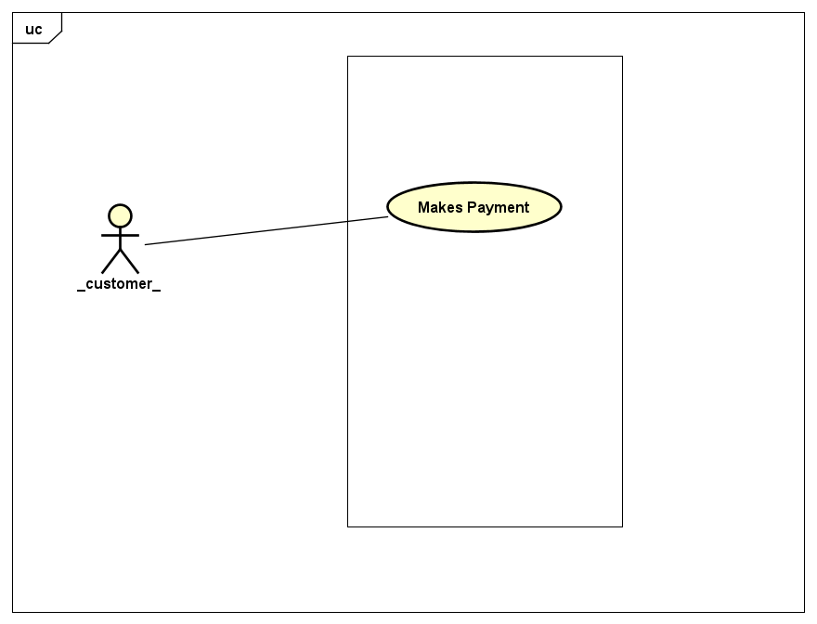

5.5 Employee Interaction with system
5.5.1 Confirmation on supplies
Name of use Case: | Florist Confirmation on Supplies
Actor(s): | Florist
Successful Completion: | - Number of flowers Confirmed available  - Type of flowers Confirmed available  - Decorations confirmed
Alternatives: | Florist fails to provide number, type of flower and decoration
Preconditions: | Order has been made
Postconditions: | Approves for delivery
Assumptions: | - Certain number of flowers are available  - Type of flowers available  - Decorations available

UML Diagram:
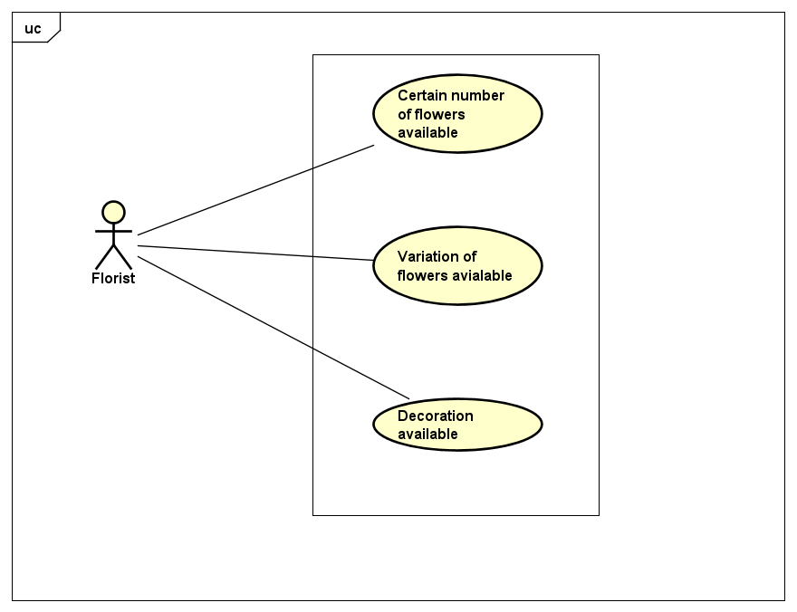

5.5.2 Checking for new Orders
Name of use Case: | Staff checks for new Orders
Actor(s): | Staff
Successful Completion: | Staff aids in placing order
Alternatives: | Staff fails to approve order
Preconditions: | Order is being made
Postconditions: | Approves for delivery
Assumptions: | Order is being made

UML Diagram:
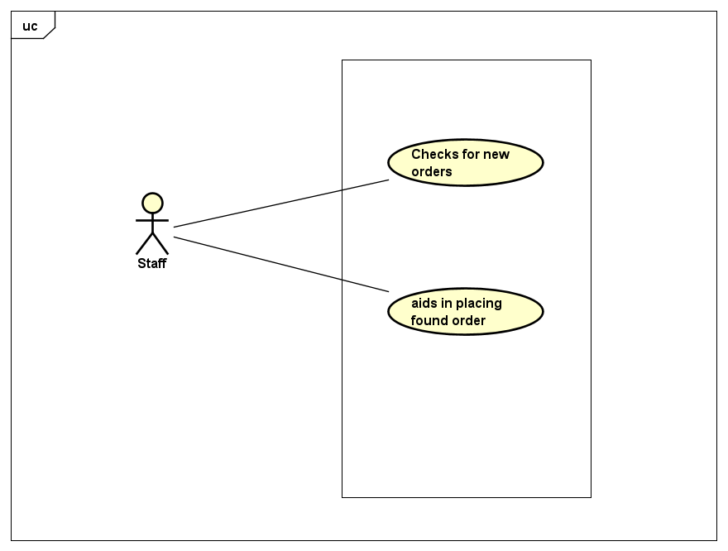

5.5.3 Notifications
Name of use Case: | Notifications to employees
Actor(s): | Arranger, Delivery Staff
Successful Completion: | - List of next day delivery provided to arranger  - List of current day delivery provided to staff
Alternatives: | - Next day delivery not provided  - Current day delivery not provided
Preconditions: | - Order approved  - Payment Made
Postconditions: | None
Assumptions: | - Orders have been placed  - Payment has been made

UML Diagram:
